**CSO ASSIGNMENT 5:-** Name-*Deepanshu Bansal*

*Roll No.-21084006*

*Department- eee idd*

1)Write a program in C to store elements in an array and print it.

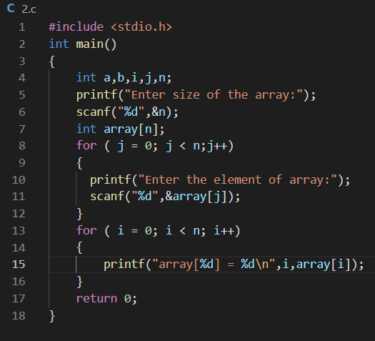

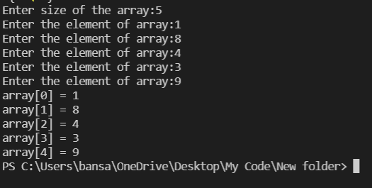

2)Write a program in C to find sum all elements of an array .

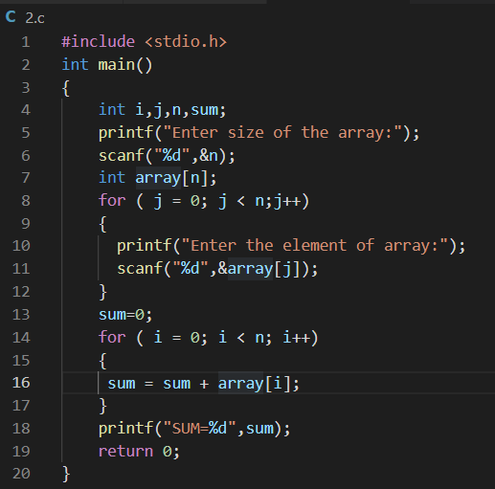

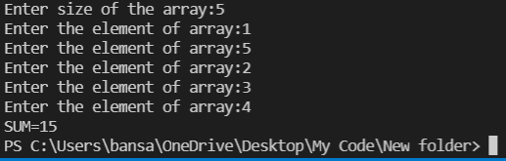

3)Write a program in c to find the maximum and minimum element in an array.

